Digital System Design Lab

Lab 4

Introduction to Quartus II and DE0

Student ID: D1166506

Name: 周嘉禾

Date: 2023/10/11

1. **Objectives**

* To learn how to use Quartus II to design logic circuit, and download the design into FPGA chip.
* To learn how to connect simple input and output devices on DE0.

1. **Theorem**
2. **Basic Properties of Boolean Operations:**

Boolean operations, a fundamental concept in digital logic and mathematics, exhibit several essential properties, including associativity, commutativity, and more. These properties are fundamental to understanding and manipulating Boolean expressions.

1. *Associative Property:*

This property states that the grouping of operands does not affect the result of an operation. In Boolean algebra, this means that (A * B) * C is equivalent to A * (B * C).

1. *Commutative Property:*

The commutative property asserts that the order of operands in an operation does not affect the outcome. For Boolean operations, this means that A + B is equivalent to B + A, and A * B is equivalent to B * A.

1. *Distributive Property*

This property describes the relationship between different Boolean operations. It states that A * (B + C) is equivalent to (A * B) + (A * C), and A + (B * C) is equivalent to (A + B) * (A + C).

1. **Quartus II Software:**

Quartus II is a powerful and widely used software tool in the field of digital design and FPGA (Field-Programmable Gate Array) programming. It provides a comprehensive environment for designing, implementing, and testing digital circuits and systems. Quartus II offers the following features:

1. *Circuit Design:*

Quartus II allows users to design digital circuits using schematic diagrams or hardware description languages like VHDL and Verilog.

1. *Synthesis:*

The software performs synthesis to convert high-level descriptions into gate-level representations, optimizing the design for implementation on FPGAs.

1. *Place and Route:*

Quartus II places and routes the circuit elements on the target FPGA device, ensuring efficient utilization of resources and satisfying timing constraints.

1. *Simulation:*

It enables users to simulate and validate their designs before programming them onto actual FPGA hardware.

1. *Programming:*

Quartus II can program the designed circuits onto FPGAs, enabling them to perform specific tasks.

1. **DE0:**

The DE0 board, also known as DE0 Development and Education board, is a popular and versatile FPGA development platform created by Terasic Technologies. It is designed for educational purposes and prototyping in the field of digital design and electronics. The DE0 board offers the following features:

1. *FPGA:*

The DE0 board is equipped with an Altera Cyclone III FPGA, providing programmable logic resources for implementing various digital designs.

1. *Memory:*

It includes SRAM and SDRAM memory, allowing for data storage and retrieval in digital applications.

1. *I/O Interfaces:*

DE0 features various I/O interfaces, including LEDs, switches, and seven-segment displays, for input and output interactions with the FPGA.

1. *Expansion Headers:*

The board offers connectors for adding additional hardware modules and peripherals, making it versatile for different projects.

1. *Educational Resources:*

Terasic provides educational materials and tutorials, making the DE0 board an excellent platform for learning digital design and FPGA programming.

1. **Objectives**
2. **Step 1:**

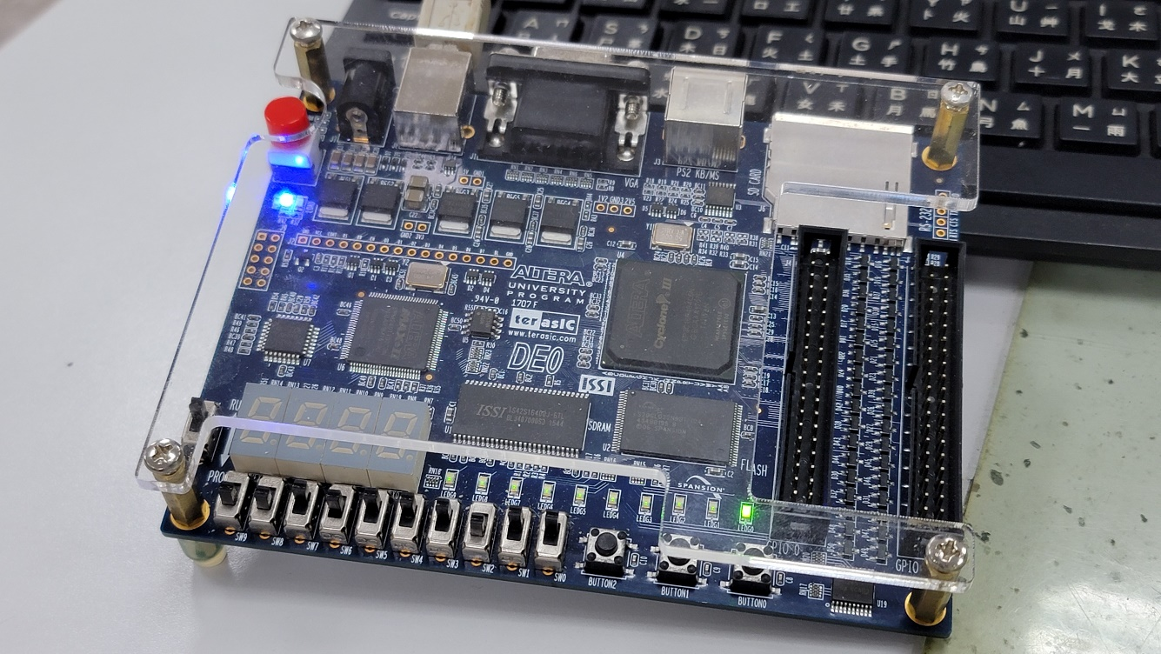

|  |  |
| --- | --- |
| A B C | F(A, B, C) |
| 0 0 0 | 0 |
| 0 0 1 | 0 |
| 0 1 0 | 0 |
| 0 1 1 | 1 |
| 1 0 0 | 0 |
| 1 0 1 | 0 |
| 1 1 0 | 1 |
| 1 1 1 | 1 |

1. **Step 3:**

|  |  |  |  |  |
| --- | --- | --- | --- | --- |
| X Y | A | B | C | D |
| 0 0 | 0 | 0 | 0 | 0 |
| 0 1 | 0 | 0 | 0 | 1 |
| 1 0 | 0 | 1 | 0 | 0 |
| 1 1 | 1 | 0 | 0 | 1 |

1. **Comment**

* Compare the amount of time it took you to complete (i.e., wire, test, and debug) Experiment Step (2) versus Experiment Step (1), expressed as a ratio (e.g., 2:1 or 1:3).

I didn’t do step 2, but in my imagination, step 2 might take more time than step 1 do since it needs to connect wires, IC circuits, etc. However, step 1 needs merely a integrating board and software. So the ratio may be 1:2.

* If there were 6 input variables instead of 3, in what way (if any) would you expect this ratio to change?

If the ratio in 3 inputs is 1:2, the ratio in 6 inputs might change to 1:10 or even higher since breadboard takes more time to connect things than software do. Moreover, the rows in truth table will increase from 8 to 64 which might also cause time increasing in the manner of connecting wires and IC. However, it could be solved easily in software because all we need is to drag and connect virtual wires instead of plugging wires.

1. **Problems & Solutions**

I am not pretty familiar with the software Quartus II, which causes me to spend lots of time to find where does something locate at. Therefore, I think I need to figure out most location of circuits.

1. **Feedback**

None